Dear Parents/Carers,

**PLAYGROUND EQUIPMENT**

The fenced off metal play equipment (see photo) next to the lower playground is very big as it has been made to junior age specifications. If you wish your junior child to be allowed to play on the equipment during school time (golden time) please return the slip below so that all supervisory staff may be informed.

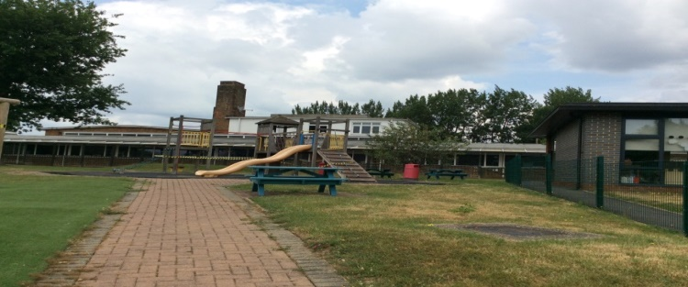

All our playground equipment meets all the necessary safety requirements but I must ask that you do not allow children of any age to play on it before or after school while you are waiting in the playground. The school cannot be responsible for accidents when children are being supervised by their parents.

Yours sincerely

J Aylen

Head Teacher

**All data provided will be stored and processed in accordance with our GDPR Data Protection Policy. See privacy notice for more information.**

…………………………………………………………………………………………………

TO: BROOKLAND JUNIOR SCHOOL

**PLAYGROUND EQUIPMENT**

I wish / I do not wish  (please tick one) my child to be allowed to use the playground equipment at playtime & lunch times.

SIGNED………………….….

CHILD’S NAME …………………... CLASS ………………

Please email back to: [admission@brooklandjnr.barnetmail.net](mailto:admission@brooklandjnr.barnetmail.net)